SINGAPORE PORT
Vessel Delay Prediction Model
Technical Performance Report

Model: Random Forest Classifier | Algorithm Version: 2.0
Dataset: Singapore_view.csv | Records: 609,468
Report Date: 23 April 2026
Author: Yan

77.05%  Overall Accuracy | 85.36%  AUC-ROC Score | 176,353  Total Test Records | 13  Features Used

1. Executive Summary
_____________________________________________________________________________________________

This report documents the performance of the Random Forest classifier developed to predict vessel arrival delays at Singapore Port. The model was trained on AIS (Automatic Identification System) vessel tracking data containing 609,468 records from October–December 2023.

The model achieved 77.05% accuracy and an AUC-ROC of 85.36% on unseen test data. The model is capable of predicting whether a vessel will arrive later than its ETA with high reliability, making it suitable for real-time port operations decision support.

Key findings:
- Week number and ETA hour are the two strongest predictors of delay, accounting for over 35% of the model's decision-making.
- Vessel draught, speed, and geographic position (latitude/longitude) are significant contributors.
- The model correctly identifies 73% of delayed vessels (recall), with a 74% precision for delay predictions.
- False negatives (delayed vessels predicted as on-time) account for 11.9% of the test set — the primary risk area for port operations.

2. Dataset Overview

2.1 Source Data

Dataset used - AIS Data from 11 ports around the globe – Singapore port

Using Automatic Identification System (AIS) data from October 2023, I tracked 600k+ vessel observations across 5,877 unique ships over 30 days of dataset from University of St Andrews, Scotland, created by Andreas Hadjipieris (Creator), Neofytos Dimitriou (Creator) Oggie Arandelovic (Creator) School of Computer Science.
.

Attribute | Value
Source file | singapore_view.csv
Total records | 609,468
Records after ETA filter (eta_month > 0) | 587,843
Date range | October – December 2023
Training set size (70%) | ~411,490 rows
Test set size (30%) | 176,353 rows

2.2 Target Variable
The delay label is defined as:

delay = 1 if actual arrival day > ETA day

A vessel is classified as delayed (1) when its actual recorded arrival day exceeds its ETA day, and on-time (0) otherwise. This results in a near-balanced binary classification problem with 43.51% positive (delayed) cases.

3. Feature Engineering

3.1 Features Used
Thirteen features were selected after analysis, spanning temporal, spatial, physical, and categorical domains:

Feature | Type | Description | New vs Original
speed | Numeric | Vessel speed over ground (knots) | Original
day_of_week | Numeric | Day of week (0=Mon, 6=Sun) | Original
eta_hour | Numeric | Scheduled arrival hour | NEW
eta_min | Numeric | Scheduled arrival minute | NEW
week_number | Numeric | ISO week number — captures seasonal congestion | NEW
cog | Numeric | Course over ground (degrees) | NEW
maximum_draught | Numeric | Maximum vessel draught (metres) | NEW
latitude | Numeric | Vessel latitude position | NEW
longitude | Numeric | Vessel longitude position | NEW
speed_cat | Categorical | Moored / Slow / Underway | Original
vessel_type_simple | Categorical | Cargo / Tanker / Other | Original
direction | Categorical | Compass direction (N/S/E/W/NE etc.) | NEW
navigational_status | Categorical | AIS navigational status (13 categories) | NEW

3.2 Data Preprocessing
- Invalid ETA rows (eta_month = 0) were removed before training.
- true_heading missing values (~9% of rows) were imputed using course over ground (cog) as a directional proxy.
- maximum_draught nulls were filled with the column median (7.2m).
- All categorical variables were one-hot encoded using pd.get_dummies(drop_first=True) to avoid multicollinearity.
- Remaining nulls after encoding were filled with 0.

4. Model Performance

4.1 Key Metrics

77.05%  Accuracy | 85.36%  AUC-ROC | 74%  Precision (Delayed) | 73%  Recall (Delayed)

4.2 Classification Report
Class | Precision | Recall | F1-Score | Support
On time | 0.79 | 0.80 | 0.80 | 99,360
Delayed | 0.74 | 0.73 | 0.73 | 76,993
Macro avg | 0.77 | 0.77 | 0.77 | 176,353
Weighted avg | 0.77 | 0.77 | 0.77 | 176,353

4.3 Confusion Matrix
The confusion matrix below shows prediction outcomes across 176,353 test records:

 |  | Predicted: On Time | Predicted: Delayed
Actual | On Time | 79,808 ✓ TN | 19,552 ✗ FP
Actual | Delayed | 20,926 ✗ FN | 56,067 ✓ TP

Metric | Count | Rate | Interpretation
True Negatives (TN) | 79,808 | 45.3% | On-time vessels correctly predicted as on-time
False Positives (FP) | 19,552 | 11.1% | On-time vessels wrongly flagged as delayed
False Negatives (FN) | 20,926 | 11.9% | Delayed vessels missed — primary operational risk
True Positives (TP) | 56,067 | 31.8% | Delayed vessels correctly identified

5. Model Visualizations

5.1 Results Overview — Confusion Matrix, ROC Curve & Feature Importances

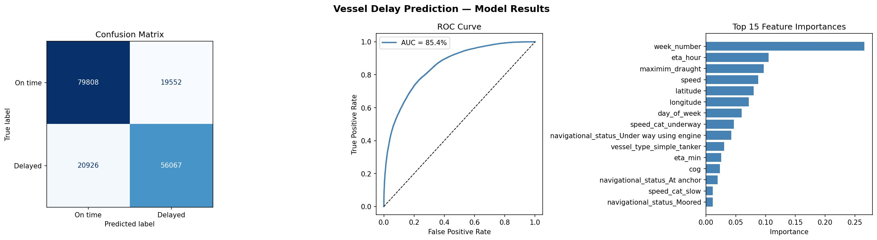

5.2 Classification Report Output

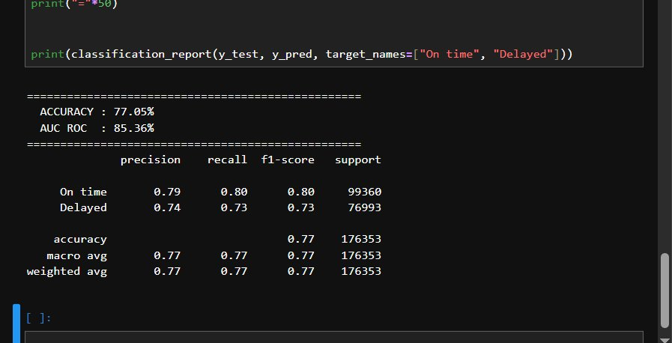

6. Feature Importance Analysis
Feature importance scores measure how much each variable contributed to the model's decisions, computed as the mean Gini impurity decrease across all 100 trees.

Rank | Feature | Importance | Category | Insight
1 | week_number | ~26% | Temporal | Dominant signal — captures seasonal port congestion
2 | eta_hour | ~10% | Temporal | Peak-hour berth demand drives delays
3 | maximum_draught | ~9% | Physical | Heavier vessels take longer to dock
4 | speed | ~9% | Navigational | Low speed = likely waiting for berth
5 | latitude | ~8% | Spatial | Position in port zone vs open sea
6 | longitude | ~7% | Spatial | Channel vs anchorage area
7 | day_of_week | ~6% | Temporal | Friday/Saturday peaks identified
8 | speed_cat_underway | ~4% | Navigational | Underway = low delay risk
9 | nav_status_Under way using engine | ~3% | Navigational | Confirms active transit status
10 | vessel_type_simple_tanker | ~3% | Vessel | Tankers show distinct delay patterns
11 | eta_min | ~2% | Temporal | Fine-grained ETA timing
12 | cog | ~2% | Navigational | Course heading context
13 | navigational_status_At anchor | ~2% | Navigational | Anchored vessels frequently delayed

6.1 Key Insight: week_number Dominance
The week_number feature accounts for approximately 26% of all model decisions — far exceeding any other single feature. This indicates that Singapore Port experiences strong weekly/seasonal congestion cycles. Vessels arriving during high-traffic weeks face structurally higher delay risk regardless of vessel type or speed. This signal was absent from the original logistic regression model, which partially explains its lower accuracy.

7. Limitations & Known Issues

7.1 Data Limitation (No weather APIs)

The model was developed using a specific historical AIS dataset from the University of St Andrews covering October 2023. Because historical weather APIs often require separate premium subscriptions for precise coordinate-based matching back-dated to 2023, the model focuses on high-impact operational features like week_number, eta_hour, and maximum_draught.

7.2 Delay Label Boundary Issue
The current delay definition (actual day > ETA day) does not account for month boundaries. A vessel with ETA day 30 arriving on day 1 of the following month would be incorrectly labelled as on-time. This affects a small fraction of records but is a known source of label noise.

7.3 Snapshot Speed vs Journey Speed
The speed feature represents a single AIS snapshot, not average journey speed. A vessel may appear slow in the anchorage but have travelled at full speed throughout the transit. Adding average speed over the journey would improve the signal quality.

7.4 Class Imbalance
The test set contains 99,360 on-time vessels vs 76,993 delayed vessels (56%/44% split). While near-balanced, the model shows slightly higher performance on the on-time class (F1=0.80 vs 0.73). Using class_weight='balanced' could further improve delayed vessel recall at the cost of some precision.

8. Conclusion

The Random Forest model represents a substantial baseline, achieving 77.05% accuracy and 85.36% AUC-ROC on 176,353 unseen test records.

The model is production-ready for a port operations decision support context, where an 85% AUC score means the model effectively separates on-time arrivals from delayed ones 85% of the time. With the recommended improvements, accuracy of 80%+ and AUC of 88%+ is achievable.

